**Assignment Questions**

***Instructions:***

1. *Write the answers in a copy, scan and make a single pdf. Upload it in the location mentioned in mail.*
2. *As evident from the questions, there is not much scope to copy each other’s assignments. Chances that problem parameters (for example - sampled values, MAC values, sequence no, acknowledgement number, window size or speed of hosts and token rates etc.) will be same for two persons is extremely rare. Thus, please make sure you solve the problems yourselves.*

**Module 1**

**Q1.** Show the steps to convert the following analog signal to digital using PCM. Assume the number of levels you want and the values of X and Y axis and the sampling points. Refer to the example in Forouzan and show all the values, namely – Normalized PAM values, Normalized quantized values, Normalized error , quantization code and finally the encoded words.

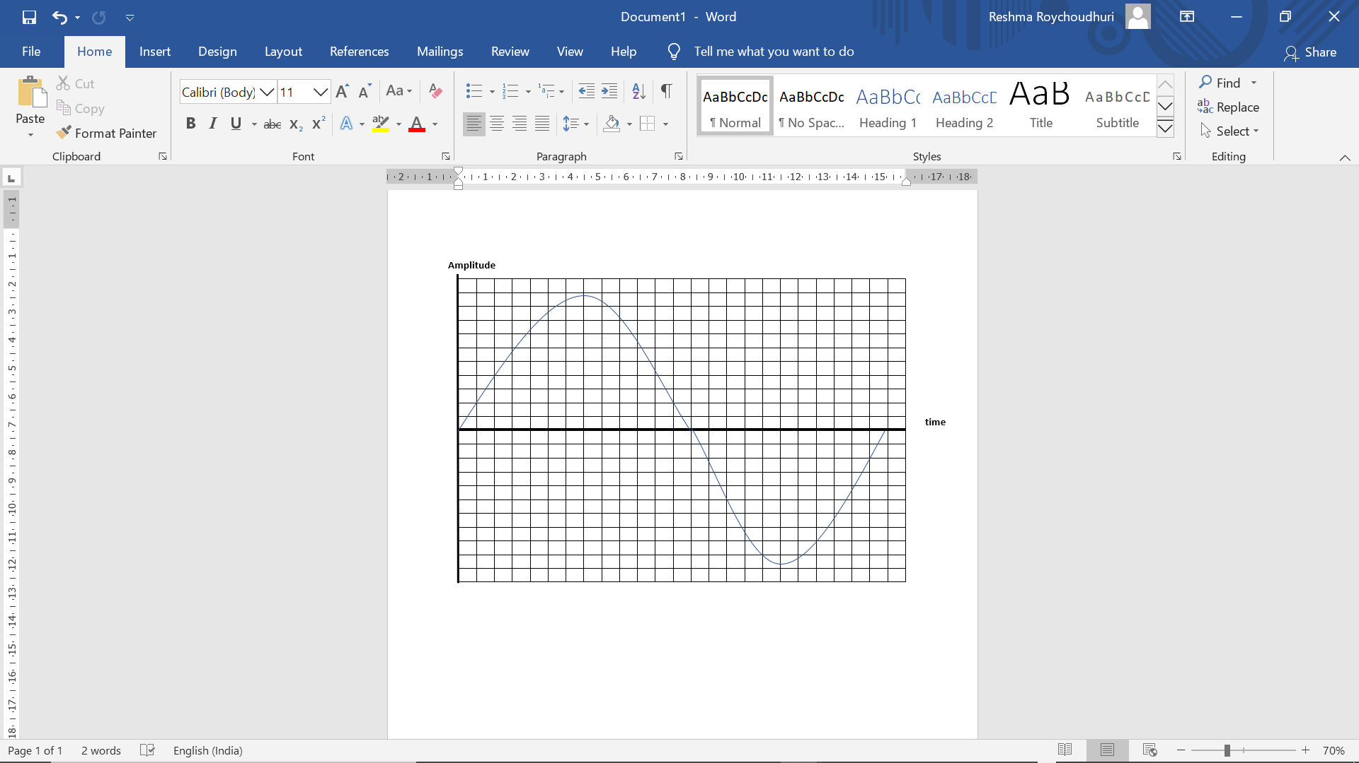

**Q2.** **a)** Which line coding method would you use to transmit the above signal and why?

**b)** Show the transmission of 2 encoded words with the line code of your choice.

**Module 2**

**Q3.** **a)** What is (are) the MAC address (es) of your machine?

**b)** What command did you use to find the information?

**c)** How many hops does it take for your computer to reach facebook.com server? Write the command and the first 4 hops it took.

**d)** Assume a source host and a destination host 2 network away from each other. Assume the start Mac address is of your machine. Draw a figure representing clearly how the hop to hop address change from the source to destination.

**Q4)** **a)** A network has a bandwidth of 2 Mbps. It takes 15 ms for 1 bit to make a round trip. Find the bandwidth delay product. Each frame is 1000 bits in length. Find out the link utilization.

**b)** Assume now that Go Back N is used as algorithm in the above example. Window size is 15 frame. What is the link utilization now?

**Module 3**

**Q5)** An organization is granted the block 130.34.12.64/26. The organization needs to have four subnets. What are the subnet addresses and the range of addresses for each subnet?

**Q6)** The following the routing table in a router: -

**Prefix Output Interface Identifier**

131.16.0.0/12 3

131.28.0.0/14 5

131.19.0.0/16 2

131.22.0.0/15 1

What is wrong with the table? This router receives a packet with address 131.23.151.76 for routing. Explain the problem with respect to this incoming packet and re-arrange the table.

**Module 4**

**Q7)** **a)** Draw a typical communication between a server and a client. Diagram should contain connection establishment (using 3-way handshaking protocol), data exchange (should include segment no, ack no, window advertisement and any other flag as appropriate) and connection termination (using 3-way handshaking protocol).

Also mark in the diagram where retransmission timer and time wait timers are used

**b)** With respect to your diagram explain the use of keep alive timer.

**Q8)** Imagine 4 hosts that use a combination of token bucket and leaky bucket algorithms for traffic shaping and policing. Assume all relevant figures required (for example – data rate of hosts, token rate, max token capacity, idle time of hosts, leaky bucket output rate etc and any other aspect needed). Draw a diagram to depicting the above scenario.